ASSIGNMENT-14.1

NAME :- P.NISHANTH

ROLL NO :- 2403A52066

BATCH N0 :- 03

Task 1: Create a Responsive Web Page Layout
Instructions:
- Design a basic web page layout with a header, main content area, and footer using HTML and CSS.
- Use AI to assist in generating responsive CSS for different screen sizes.
- Ensure the layout is clean and visually organized.

CODE:-
<!DOCTYPE html>
<html lang="en">
<head>
<meta charset="UTF-8">
<meta name="viewport" content="width=device-width, initial-scale=1.0">
<title>Responsive Web Page</title>
<style>
*{margin:0;padding:0;box-sizing:border-box;} body{font-family:Arial,sans-serif;} header,footer{background:#0077b6;color:white;text-align:center;padding:15px;} nav ul{list-style:none;display:flex;justify-content:center;gap:20px;margin-top:10px;} nav a{color:white;text-decoration:none;font-weight:bold;} main{text-align:center;padding:20px;} main img{width:100%;max-width:500px;border-radius:10px;margin-top:10px;} footer{font-size:0.9em;}
@media(max-width:768px){
nav ul{flex-direction:column;gap:10px;}
}
</style>
</head>
<body>

<header>
<h1>My Responsive Page</h1>
<nav>
<ul>
<li><a href="#">Home</a></li>
<li><a href="#">About</a></li>
<li><a href="#">Services</a></li>
<li><a href="#">Contact</a></li>
</ul>
</nav>
</header>

<main>
<h2>Welcome!</h2>
<p>This is a simple responsive web page using HTML and CSS.</p>
<img src="https://via.placeholder.com/500x250" alt="Sample Image">
</main>

<footer>
<p>&copy; 2025 My Website | Contact: info@example.com</p>
</footer>

</body>
</html>

OUTPUT -
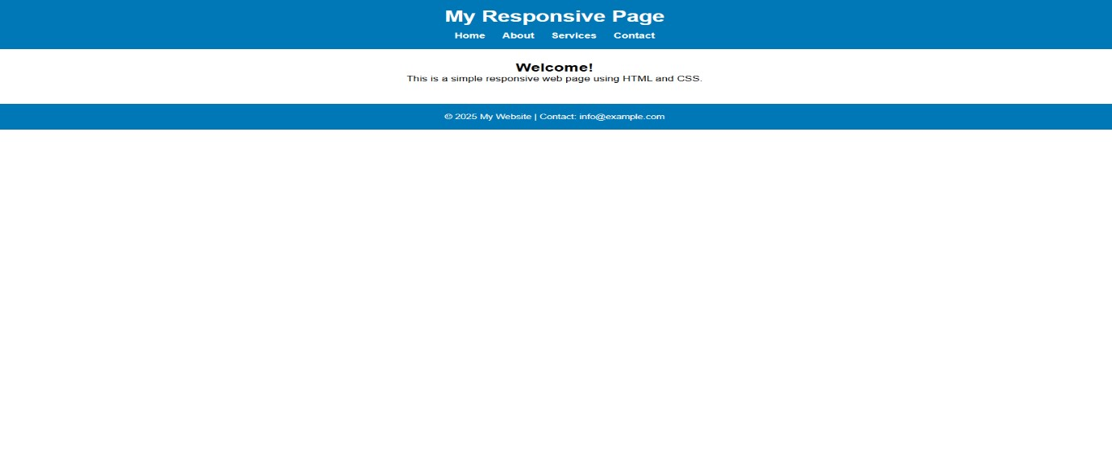
OBSERVATION :
- The HTML document defines the structure of the web page.
- The <head> section includes the page title, character encoding, and CSS styling.
- The <meta viewport> tag makes the page adjust to mobile and tablet screens.
- The <header> contains the website title and navigation links.
- The navigation menu helps users move between different sections.
- The <main> section holds the main content like headings, text, and an image.
- The <footer> displays copyright and contact information.
- CSS styles are written inside the <style> tag to give color, spacing, and alignment.
- The layout uses the flexbox property to arrange navigation links in a line.
- The background color, text color, and padding make the design clean and readable.
- The image in the main section is centered and adjusts to screen width.
- Media queries in CSS make the layout responsive for tablets and mobiles.
- On small screens, navigation links appear vertically for better readability.
- The overall design ensures that the web page looks good on all screen sizes.
- The page is simple, responsive, and visually organized with basic HTML and CSS.

Task 2: Interactive Button with JavaScript
Instructions:
- The code is clean and well-commented Create a button on a web page.
- Use AI to generate JavaScript code that displays an alert message when the button is clicked.
- Ensure the code is clean and well-commented
CODE :
<!DOCTYPE html>
<html lang="en">
<head>
<meta charset="UTF-8">
<meta name="viewport" content="width=device-width, initial-scale=1.0">
<title>Interactive Button</title>
<style>
/* Simple styling for the button */ body { font-family: Arial, sans-serif; text-align: center; margin-top: 100px;
}
button { background-color: #4CAF50;
color: white; border: none; padding: 12px 24px; font-size: 16px; border-radius: 8px; cursor: pointer;
}
button:hover { background-color: #45a049;
}
</style>
</head>
<body>
<!-- Button Element -->
<button id="alertButton">Click Me!</button>

<script>
// Get the button element by its ID const button = document.getElementById("alertButton");

// Add a click event listener to the button button.addEventListener("click", function() { // Display an alert message when button is clicked alert("Hello! You clicked the button!");
});
</script>
</body>
</html>
OUTPUT :

EXPLANATION :
- HTML structure created with <button> element.
- CSS styles the page and button for a clean look.
- JavaScript selects the button using its id.
- An event listener waits for a "click" action.
- When clicked, an alert message is shown to the user.
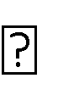 Code is properly commented and organized for readability.
Task 3: Form with Validation Instructions:
- Design a contact form with fields: Name, Email, Message.
- Use AI to generate JavaScript code for form validation (e.g., non-empty fields, valid email format).
- Add inline error messages if input is invalid.
CODE :
<!DOCTYPE html>
<html lang="en">
<head>
<meta charset="UTF-8">
<meta name="viewport" content="width=device-width, initial-scale=1.0">
<title>Contact Form with Validation</title>
<style>
/* Basic page styling */ body { font-family: Arial, sans-serif; margin: 50px; background-color: #f9f9f9;
}

h2 { text-align: center;
}

form { max-width: 400px; margin: auto; background: #fff; padding: 20px; border-radius: 10px; box-shadow: 0 0 10px rgba(0,0,0,0.1); }

label { display: block; margin-top: 10px; font-weight: bold;
}

input, textarea { width: 100%; padding: 8px; margin-top: 5px; border: 1px solid #ccc; border-radius: 5px;
}

button { margin-top: 15px; padding: 10px 15px; background-color: #4CAF50; color: white; border: none; border-radius: 5px; cursor: pointer; width: 100%;
}

button:hover { background-color: #45a049;
}

/* Error message styling */
.error {
color: red; font-size: 13px;
}

/* Success message */ .success { text-align: center; color: green; font-weight: bold;
}
</style>
</head>
<body>

<h2>Contact Form</h2>

<form id="contactForm">
<label>Name:</label>
<input type="text" id="name">
<span class="error" id="nameError"></span>

<label>Email:</label>
<input type="text" id="email">
<span class="error" id="emailError"></span>

<label>Message:</label>
<textarea id="message" rows="4"></textarea>
<span class="error" id="messageError"></span>

<button type="submit">Submit</button>
</form>

<p class="success" id="successMsg"></p> <script> // Get form elements const form = document.getElementById("contactForm"); const name = document.getElementById("name"); const email = document.getElementById("email"); const message = document.getElementById("message");

const nameError = document.getElementById("nameError"); const emailError = document.getElementById("emailError"); const messageError = document.getElementById("messageError"); const successMsg = document.getElementById("successMsg");

// Function to validate email format using regex function isValidEmail(email) { return /^[^\s@]+@[^\s@]+\.[^\s@]+$/.test(email);
}

// Validate form on submit form.addEventListener("submit", function(e) {
e.preventDefault(); // Prevent page reload

// Reset error messages nameError.textContent = ""; emailError.textContent = ""; messageError.textContent = ""; successMsg.textContent = "";

let isValid = true;

// Check name if (name.value.trim() === "") { nameError.textContent = "Name is required"; isValid = false;
}

// Check email if (email.value.trim() === "") { emailError.textContent = "Email is required"; isValid = false;
} else if (!isValidEmail(email.value.trim())) { emailError.textContent = "Invalid email format";
isValid = false;
}

// Check message if (message.value.trim() === "") { messageError.textContent = "Message cannot be empty";
isValid = false;
}

// If all valid if (isValid) {
successMsg.textContent = "Form submitted successfully!"; form.reset(); // Clear form fields
}
});
</script>
</body>
</html>
OUTPUT :
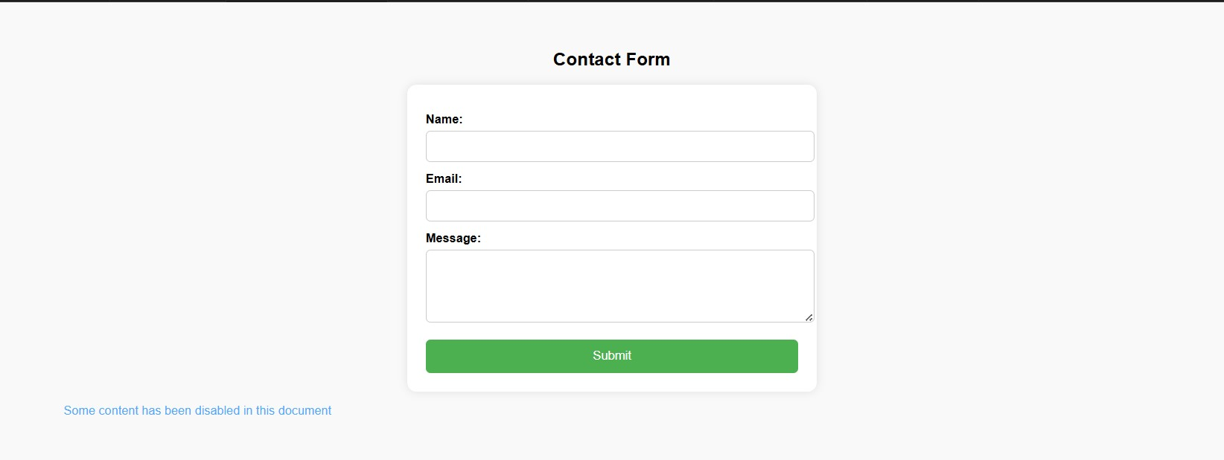

EXPLANATION
:

- HTML form created with fields: Name, Email, Message.
- CSS adds a simple, clean layout and styles for errors and success messages.
- JavaScript validates each field on form submission.
- Email validation uses a regular expression (regex).
- Inline error messages appear below invalid fields.
- If all fields are valid, a success message is displayed, and the form reset.

Task 4: Dynamic Content Generation
Instructions:
- Create a list of items (e.g., product names) using HTML.
- Use AI-generated JavaScript to dynamically add or remove items from the list when a button is clicked.
CODE:

<!DOCTYPE html>
<html lang="en">
<head>
<meta charset="UTF-8">
<meta name="viewport" content="width=device-width, initial-scale=1.0">
<title>Dynamic List Example</title>
<style>
/* Page styling */ body { font-family: Arial, sans-serif; text-align: center; margin-top: 50px; background-color: #f9f9f9;
} ul {
list-style-type: none; padding: 0;
} li {
background-color: #e0f7fa; margin: 5px auto; padding: 10px; width: 200px; border-radius: 5px; box-shadow: 0 0 5px rgba(0,0,0,0.1);
}

button { margin: 10px; padding: 10px 15px; font-size: 16px; border: none; border-radius: 5px; cursor: pointer;
}

#addBtn { background-color: #4CAF50; color: white;
}

#removeBtn { background-color: #f44336; color: white;
}

button:hover { opacity: 0.9;
}
</style>
</head>
<body>

<h2>Product List</h2>

<!-- List of items -->
<ul id="itemList">
<li>Product 1</li>
<li>Product 2</li>
<li>Product 3</li>
</ul>

<!-- Buttons to add or remove items -->
<button id="addBtn">Add Item</button>
<button id="removeBtn">Remove Item</button>

<script>
// Get references to HTML elements const itemList = document.getElementById("itemList"); const addBtn = document.getElementById("addBtn"); const removeBtn = document.getElementById("removeBtn"); // Counter to keep track of added items let itemCount = 3;

// Function to add a new item dynamically addBtn.addEventListener("click", function() { itemCount++; // Increase count const newItem = document.createElement("li"); // Create new list item newItem.textContent = "Product " + itemCount; // Add text to new item itemList.appendChild(newItem); // Add to list
});

// Function to remove the last item dynamically removeBtn.addEventListener("click", function() { if (itemList.lastElementChild) { // Check if list has items itemList.removeChild(itemList.lastElementChild); // Remove last item itemCount--; // Decrease count
} else {
alert("No more items to remove!"); // Show alert if list empty
}
});
</script>
</body>
</html>

OU
TPU
T:

EXPLANATION:
- Created an initial list (<ul>) with three product items.
- Added two buttons — Add Item and Remove Item.
- JavaScript increases the counter and adds a new <li> when Add Item is clicked.
- Remove Item deletes the last <li> element if the list is not empty.
- The list updates instantly without reloading the page.
- Clean, commented, and beginner-friendly implementation.

Task 5: Styled Modal Popup
Instructions:
- Use AI to generate a modal popup that opens when a button is clicked.
- Style the modal using CSS with a semi-transparent overlay.
- Include a close button that hides the modal.

CODE:
<!DOCTYPE html>
<html lang="en">
<head>
<meta charset="UTF-8">
<meta name="viewport" content="width=device-width, initial-scale=1.0">
<title>Styled Modal Popup</title>
<style>
/* Basic page setup */ body { font-family: Arial, sans-serif; text-align: center; background-color: #f4f4f4; margin-top: 100px;
}

/* Button styling */
#openModalBtn { padding: 10px 20px; background-color: #4CAF50; color: white; border: none; border-radius: 8px; cursor: pointer; font-size: 16px;
}

#openModalBtn:hover { background-color: #45a049;
}

/* Modal background overlay (hidden by default) */
.modal { display: none; /* Hidden until triggered */ position: fixed; z-index: 1; /* Stay on top */
left: 0; top: 0; width: 100%; height: 100%; overflow: auto; background-color: rgba(0, 0, 0, 0.5); /* Semi-transparent overlay */
}

/* Modal content box */ .modal-content { background-color: #fff; margin: 15% auto; padding: 20px; border-radius: 10px; width: 80%; max-width: 400px; box-shadow: 0 5px 15px rgba(0, 0, 0, 0.3); position: relative; animation: fadeIn 0.3s;
}

/* Close button styling */
.close { position: absolute; top: 10px; right: 15px; font-size: 22px; font-weight: bold; color: #333; cursor: pointer;
}

.close:hover { color: red;
}

/* Fade-in animation */ @keyframes fadeIn { from { opacity: 0; transform: scale(0.9); } to { opacity: 1; transform: scale(1); }
}
</style>
</head>
<body>

<!-- Button to open the modal -->
<button id="openModalBtn">Open Modal</button> <!-- Modal structure -->
<div id="myModal" class="modal">
<div class="modal-content">
<span class="close">&times;</span>
<h2>Welcome!</h2>
<p>This is a styled modal popup window. Click “X” or outside the box to close it.</p>
</div>
</div>

<script>
// Get elements const modal = document.getElementById("myModal"); const openBtn = document.getElementById("openModalBtn"); const closeBtn = document.querySelector(".close");

// When the "Open Modal" button is clicked openBtn.addEventListener("click", function() { modal.style.display = "block";
});

// When the "X" button is clicked closeBtn.addEventListener("click", function() { modal.style.display = "none";
});

// Close modal when clicking outside the content area window.addEventListener("click", function(event) { if (event.target === modal) { modal.style.display = "none";
}
});
</script>
</body>
</html>

OUTPUT:

EXPLANATION:

- A button labeled “Open Modal” is created.
- Modal box and semi-transparent overlay are styled using CSS.
- JavaScript shows the modal when the button is clicked.
- Clicking the “X” or outside the modal closes it.
- Smooth fade-in animation makes it visually appealing.
- Page doesn’t reload — all updates happen dynamically.

